Computer Science
Mrs A Sulthana, Ms A Veiou & HoD- Mr K Govender
Overview of the subject | Computer science covers both programming (Python) and theory and it will give your child sought-after digital knowledge and skills for the workplace and for everyday life.
Methods of Assessment: | Two exams at the end of Yr 11. OCR Exam board  Paper 1 – Theory paper – 80 marks, 90 mins (50% weighting)  Paper 2 – Programming paper – 80 marks, 90 min (50% weighting)
Key Content and Topics Covered | Paper 1- Computer systems:  Section 1- Systems architecture, memory & storage  Section 2- Data representation  Section 3- Computer networks, connections and protocols,  Section 4- Network security & system software,  Section 5- Ethical & environmental issues.  Paper 2- Computational thinking, algorithms & programming:  Section 6- Algorithms,  Section 7- Programming,  Section 8- Logic & languages.
Skills developed | Computational thinking is at the core of computer science, which helps students to develop the skills to solve problems, design systems to solve a problem and understand human and machine intelligence (AI).  Students will apply the principles they learn in the classroom to real-world systems in an exciting and engaging way.
Progression routes: | A-levels or BTEC IT (Level 3), University degree or Apprenticeship.
Why choose this subject | Studying computer science at GCSE level is a great choice because it equips you with valuable problem-solving, critical thinking, and programming skills that are applicable across various careers, not just in IT, while also providing a strong foundation for further study in the field and opening doors to a wide range of potential job opportunities in the technology sector.
Course requirements | No prior skills required, EXCEPT, a willingness to learn and develop new skills, preparing you for the future.
Student Testimonial | (Yr 10 student-quote in Python programming)  isComputerScienceGood = true  print("It's a very fun and rewarding subject to pick")
Additional Information | 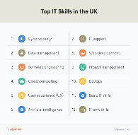  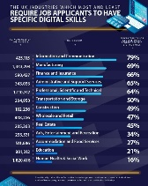  We use the following resource websites:  craigndave.org – for videos on EVERY topic  w3schools.com – FREE Python programming tutorials

