Teachers: Ms E Thoulass, Miss Keane, Mr Kirby, Miss Welch.
Methods of Assessment: | GCSE History Course at Cardinal Newman follows the Pearson Edexcel Specification. The qualification is linear which means that students will sit three exams at the end of the course in the May/June of their final year. Details of the exam timings and course weighting is as follows:  Paper 1: British Thematic & Historic Environment: Medicine in Britain, c1250 to present-The British sector of the Western Front: injuries, treatment, and the trenches. (30% 1 hour 15 mins).  Paper 2: Period Study & British Depth Study: The American West, c1835–c1895​ & Anglo-Saxon & Norman England c1060-88. (40% 1 hour 45 mins).  Paper 3: Modern Depth Study: Weimar and Nazi Germany, 1918–39. (30% 1 hour 20 mins).
Course Outline: | Paper 1. British Thematic Study with Historic Environment (30%) - Medicine in Britain, c1250 to present with The British sector of the Western Front, 1914–18 Trench warfare: injuries, treatment and the trenches.  What did people believe caused disease?  How did people look for a natural explanation of illness?  How did people treat and prevent disease and illness?  Paper 2. Period Study (20%) - The American West, c1835–c1895  · Who were the Plains Indians and what was their way of life?  · How did this change?  · The development and settlement of the West  British Depth Study ( 20%)- Anglo-Saxon and Norman England, c1060–88  · What was Anglo-Saxon England like?  · What happened at the battle of Hastings and what were the consequences?  Paper 3. Modern Depth study (30%) – Weimar and Nazi Germany 1918-1939.  . What was the nature of the Weimar Republic?  · How did the Nazis come to power?  · How did they govern Germany?  · Was there any resistance to the Nazis?  · Why were people persecuted in Nazi Germany?  Choosing History / Student / Historical Association
Progression routes: | Choosing History opens the door to a host of opportunities! Upon completion of this two-year GCSE course, students will have the skills and experience to progress onto A-Level and beyond. History A level is a facilitator subject for university applications. Our students can and do of course choose to study History at university, including Oxbridge.  Careers linked to the study of history include Law; Media & journalism; Architecture; National & Local government; The Diplomatic & The Civil service​; Museums, galleries, libraries, universities​; Archaeology, conservation; Police & armed forces​. For more information please see the following link: Careers with History / Historical Association​
How you will learn | Students will learn through discussion; questioning; paired and group work; analytical & critical thinking; handling evidence to make informed decisions; Communicating ideas and thoughts in a way that makes sense to others – whether that be verbally or in essays or illustrated reports.
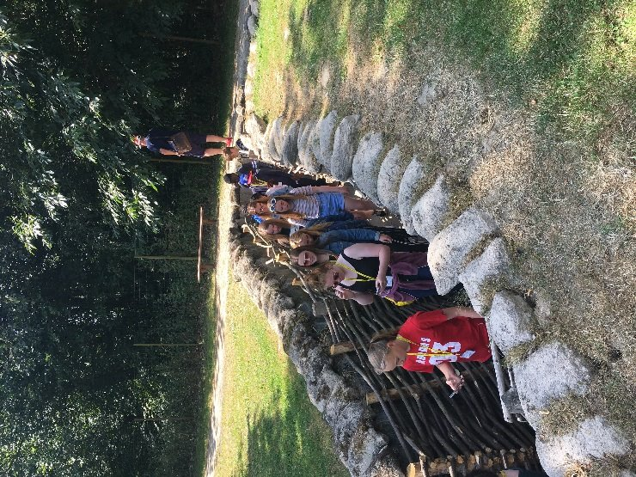
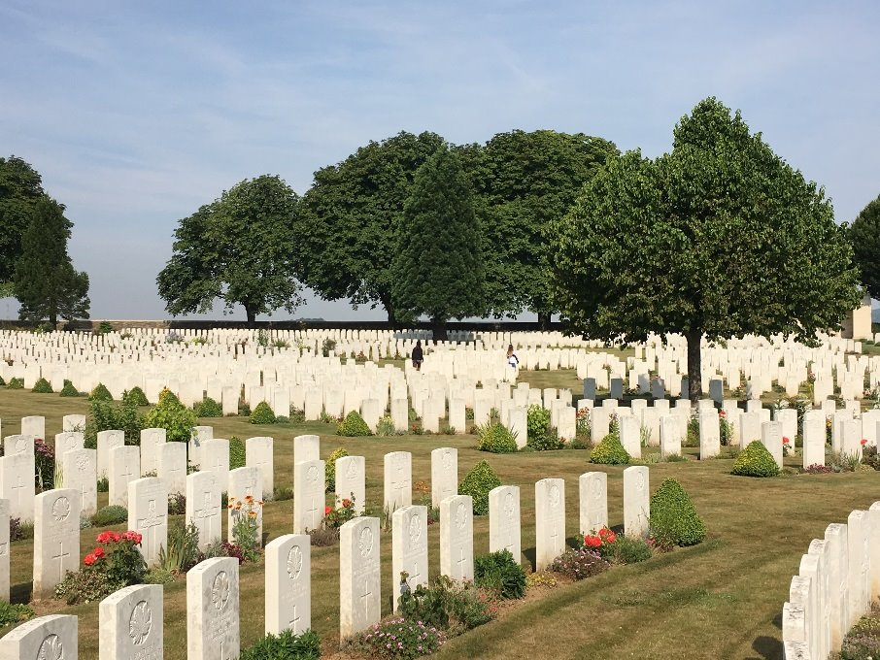
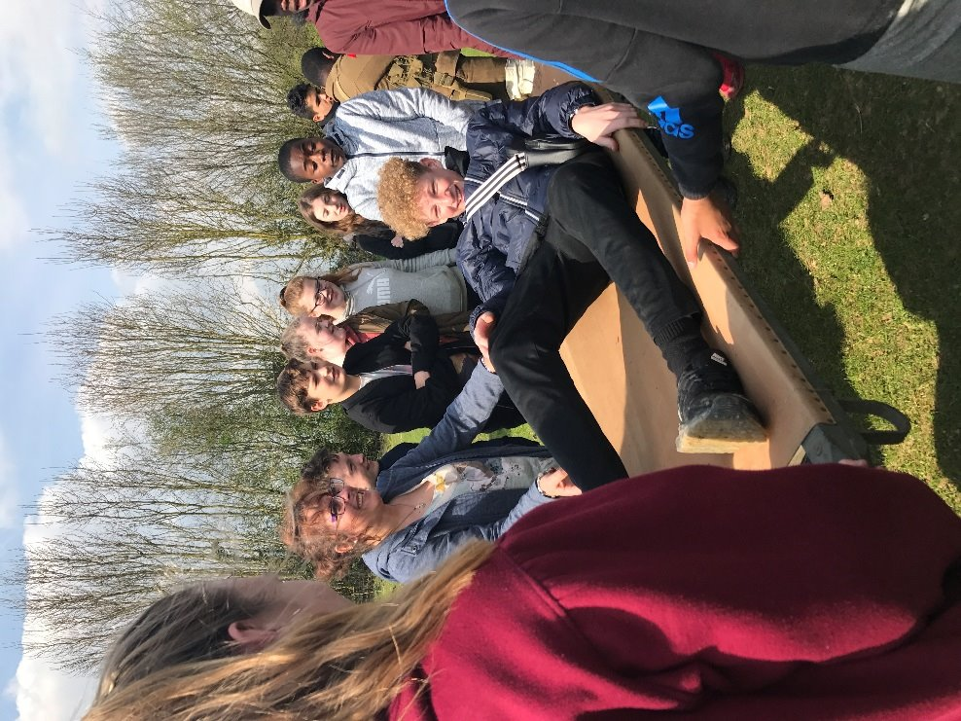
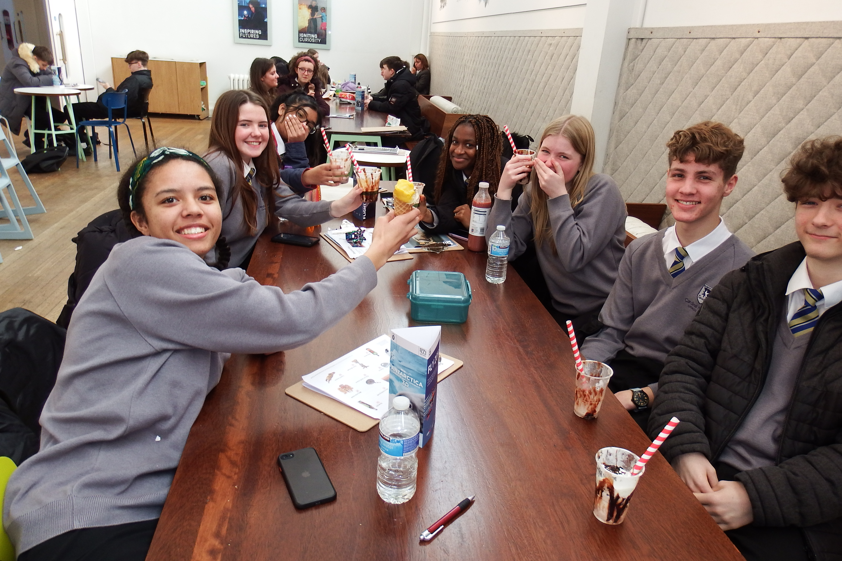
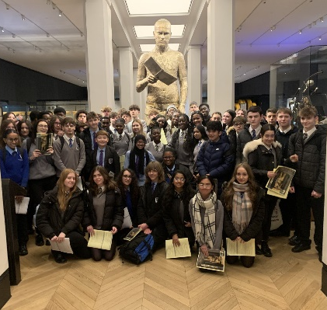

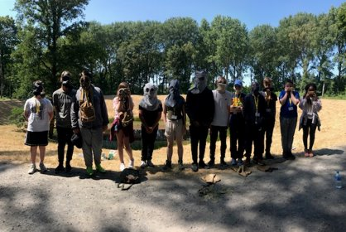

GCSE History trip to the Science Museum, London & World War 1 Battlefields Trip Belgium & France.
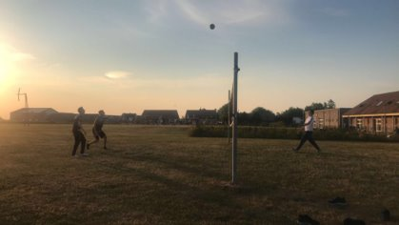

For whatever was written in former days was written for our instruction, so that by steadfastness and by the encouragement of the scriptures we might have hope. Romans 15:4​

