GCSE Media Studies
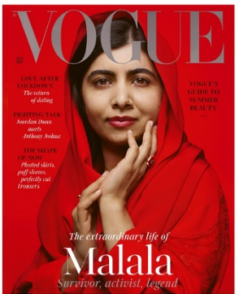
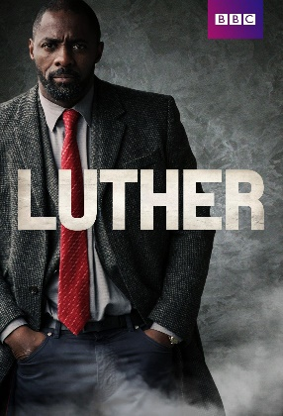
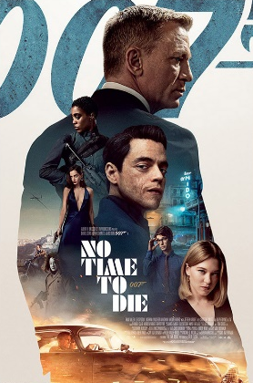
Teachers: Mrs Walker (Head of Department), Mrs Frazer and Miss Blackbird
Methods of  Assessment: | 2 Exams at the end of Year 11 worth 70%  1 Non-Exam Assessment project worth 30%  Exams  Component 1: Exploring the Media (1 hour 30 minutes) 40%  Component 2: Understanding Media Forms and Products (1 hour 30 minutes) 30%  Non-Exam Assessment (Coursework)  Component 3: Creating Media Products 30%
Course Outline: | Year 10: Component 1 and NEA  Adverts, Magazines, Film Posters, Newspapers, Radio, Video Games,  Cross-media production. Students research, plan and produce a media product such as a magazine cover or film poster.  Year 11: Component 2  TV Crime Drama including Luther. Music Videos including Stormzy, Taylor Swift and TLC plus their websites and social media.
Progression routes: | Media students achieve excellent results which can open many doors, wherever you want to go next! Some great post-16 options include:  - A Levels in English, Psychology, History, Sociology, Media Studies – and many more!  - Vocational options such as the Creative iMedia CTEC, Criminology or Health & Social Care,
How you will learn: | - Lessons will combine note-taking, small group tasks, independent computer research and completing practice exam questions.  - We use booklets to guide you through lessons, giving you all the information you need without lots of copying out!  - All lessons are uploaded to Teams so you can follow along during the lesson and use these to catch up if you miss a lesson.  - Practical tasks for coursework, such as taking photographs, can be done independently or in small groups  - Seneca online quizzing
Why choose Media Studies?
- We are an excellent Department and achieve fantastic GCSE results.
- We study modern and relevant topics such as Fortnite, James Bond film posters and GQ magazine covers.
- We have a range of equipment that students are free to use at any time including access to Adobe Creative Cloud, Ring lights, cameras, photographic backgrounds etc.
- The course develops analytical skills which support progress in subjects such as English and History.
- We offer the creative element of coursework which allows students to be innovative and showcase their practical skills.

Cambridge National Creative iMedia
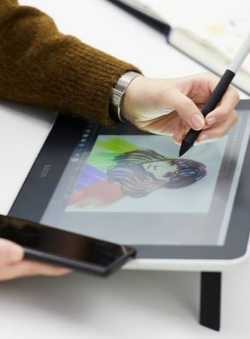
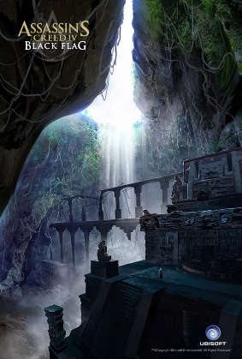
Teachers: Mrs Walker (Head of Department), Mrs Frazer and Miss Blackbird
Methods of  Assessment: | 2 Non-Exam Assessment assignments worth 60%  1 Exam at the end of Year 11 worth 40%  Non-Exam Assessment (Coursework)  Characters and Comics 35%  Visual Identity and Digital Graphics 25%  Exams  Creative iMedia in the media industry (1 hour 30 minutes) 40%
Course Outline | Year 10:  Characters and Comics  Plan, create and review characters and comics.  Visual Identity and digital graphics  Develop, plan and create visual identity and digital graphics.  Year 11: Creative iMedia in the media industry  Topics include: the media industry, factors influencing product design, pre-production planning, distribution considerations.
Progression routes: | Media students achieve excellent results which can open many doors, wherever you want to go next! Some great post-16 options include:  - Vocational options such as the Creative iMedia CTEC qualification, Criminology or Health and Social Care  - An A Level in Media Studies
How you will learn: | - Many lessons will focus on you completing work independently on the computer such as producing your own comic or designing a loading screen for a video game.  - All lessons are uploaded to Teams so you can follow along during the lesson and use these to catch up if you miss a lesson.  - Practical tasks for coursework, such as taking photographs, can be done independently or in small groups  - Know it all Ninja online quizzing
Why choose Media Studies?
- We are an excellent Department and achieve fantastic results.
- The focus on assignments means teachers can guide students to excellence and relieves the pressure of exams.
- We have a range of equipment that students are free to use at any time including access to Adobe Creative Cloud, Ring lights, cameras, photographic backgrounds etc.
- Develops skills in time management, organisation and independence.
- We offer the creative element of coursework which allows students to be innovative and showcase their practical skills.

