


English Language A’Level
Y11 into Y12 Transition Task
 | Key Information
Exam Board | Pearson Edexcel www.pearson.com
Specification Code | 9ENO - Link to specification: https://qualifications.pearson.com/content/dam/pdf/A%20Level/English%20Language/2015/Specification%20and%20sample%20assessment/a-level-english-language-specification.pdf
 | We are working towards the A’Level (not AS Level)
You are required to complete the following task to prepare you for A’Level English Language study. Present all this work neatly in a folder or as a booklet.
Task
As part of your English Language study, you will explore a range of different texts which could range from a novel extract to the back of a train ticket. Collecting a range of different texts will encourage you to respond to the language used in a real-world context.
You need to collect a range of texts with interesting language features. The aim is to create a scrap book of texts that you have analysed. Further analysis of your scrap book will take place during lessons once the course starts.
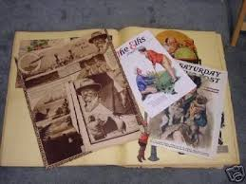
What to look for when collecting texts:
Context: Where was the text produced and received. What factors may have influenced its production or reception?
Audience: Look for a wide range of audiences – age, occupation, gender, hobbies & interests, income, family situation.
Mode: Spoken, written, multi-modal (images & texts), electronic.
Purpose: A text may have more than one purpose – describe, persuade, inform, advise, explain, argue, entertain, instruct.
Genre: magazine article, extracts from fiction texts, writing for children, advertising, food packaging, webpage, leaflet, text book, holiday brochure, social media messages, blogs.
Register: Do the texts use a high or low formality register? Evidence of slang, colloquialisms, contractions, neologisms (new words) or technical jargon.
Unusual features: Any other unusual features of the texts should be noted.
Expectation: Your scrapbook should have 10-15 different types of texts, with some analysis of each one.

Information
There are a lot of good books, written by linguists, for the general public about what language is and how it works. Below are a few, which you might wish to read; for many of them you can see the ‘Look inside’ pages on Amazon (www.amazon.co.uk) and have a sample read. If you like the sound of the book you might want to buy it, though you don’t have to.
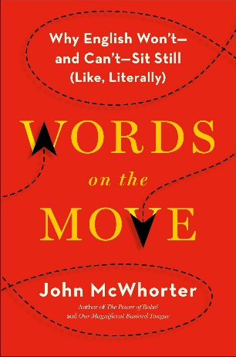
John McWhorter Words on the Move
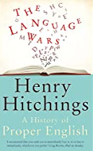

Julie Coleman The Life of Slang
Gretchen McCulloch Because Internet
David Shariatmadari Don’t Believe a Word
Henry Hitchings The Language Wars
Lane Greene You Are What You Speak
David Crystal Stories of English
Bill Bryson Mother Tongue

If you have any questions please contact Miss Fealy efealy@cardinalnewmanschool.net or Mrs Grant jgrant@cardinalnewmanschool.net.
We really look forward to meeting you when the course starts and enjoying the exploration of the English Language together.

English Department

