Safeguarding: Substance Misuse Awareness
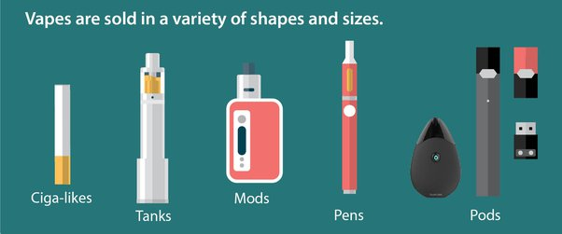
What is substance misuse?
Substance misuse refers to the use of psychoactive substances in a way that is harmful to health. This includes alcohol, vapes and illicit drugs. The use of such substances can lead to dependence where cognitive, behavioural and physiological problems develop which results in a strong desire to take the drug, difficulties in controlling use, persisting in its use despite harmful consequences, a higher priority given to drug use than to other activities. It impacts a child’s emotional well-being, concentration, self-regulation, moods and much more.
Why do young people use substances?
The most recent statistics show that at least one in six children have a mental health problem, with an increase of 50% in the likelihood of children experiencing difficulties. This links with substance abuse, as although risk-taking behaviours can be common in teenage development, we know that substance abuse and addiction can develop as a coping strategy for adverse experiences and lead children vulnerable to abuse and exploitation. Statistics from the NHS show that 40% of secondary aged pupils reported drinking alcohol. Also, just under 1 in 5 pupils reported taking drugs, with this evenly being spread between boys and girls. Pupils were most likely to have tried cannabis and volatile substances (glues, gases, solvents etc), however there were also a relatively high number of young people who had tried harmful substances unknowingly through vaping. Increasingly schools are concerned about the effects of vapes on young people. The toxins and chemicals impact young people in numerous negative ways.
What might you see?
Children and young people who are misusing substances may have:
- Changing friendship groups
- Signs of self-neglect
- Poor attendance / performance
- Lack of motivation and concentration levels/ focus
- Disengagement from hobbies / interests
- Change in appetite / eating patterns

