Annex 1

Temporary Policy Addendum:

COVID-19 school closure arrangements for Safeguarding and Child Protection at Cardinal Newman Catholic School

This Policy addendum is effective from 4th January 2021 – 18th January 2021

School Name: Cardinal Newman Catholic School
Policy owner: Michelle Chappell
Date: 03.01.2021
Date shared with staff: 03.01.2021

Context

To support public health efforts during the return to school in January, secondary schools will invoke a phased return to face-to-face provision at the start of term.

From 4th January 2021 Secondary age parents were asked to keep their children at home, wherever possible, and for schools to remain open only for those children of workers critical to the COVID-19 response - who absolutely need to attend.
Schools and all childcare providers were asked to provide care for a limited number of children - children who are vulnerable, and children whose parents are critical to the COVID-19 response and cannot be safely cared for at home.

School opening is currently set as:

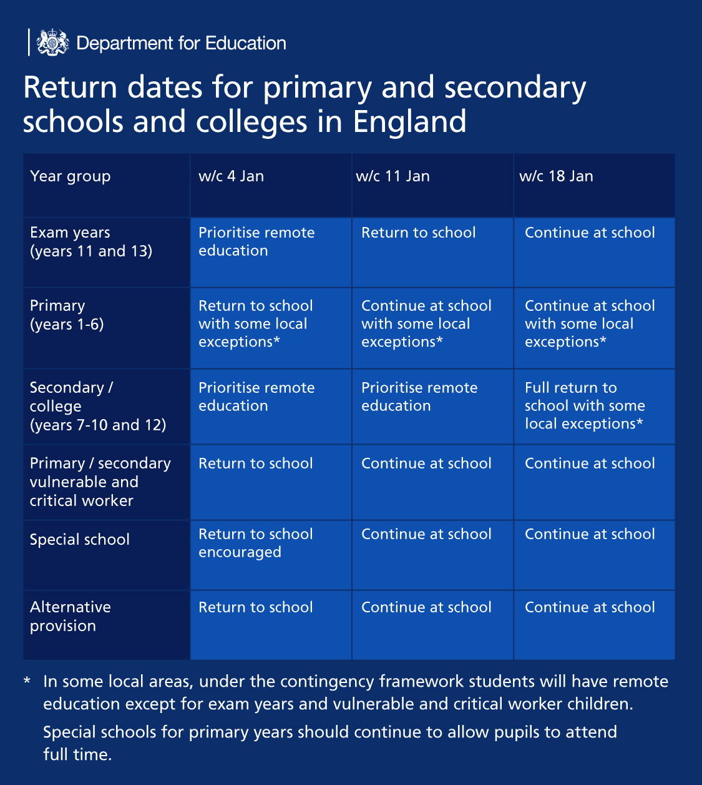

This addendum of the STACT Safeguarding and Child Protection policy contains details of our individual safeguarding arrangements in the following areas:

Cardinal Newman Catholic School is in Tier 4.

Content Table

Context 2
Vulnerable children 4
Critical workers 5
Attendance monitoring 5
Designated Safeguarding Lead 6
Reporting a concern 6
Safeguarding Training and induction 7
Safer recruitment/volunteers and movement of staff 8
Online safety in schools and colleges 8
Children and online safety away from school and college 9
Supporting children not in school 9
Supporting children in school 10
Peer on Peer Abuse 11
Support from the Multi-Academy Trust 11

Key contacts

Remain as per the STCAT Safeguarding Policy.

Vulnerable children

Vulnerable children and young people include those who:

- are assessed as being in need under section 17 of the Children Act 1989, including children and young people who have a child in need plan, a child protection plan or who are a looked-after child;
- have an education, health and care (EHC) plan;
- have been identified as otherwise vulnerable by educational providers or local authorities (including children’s social care services), and who could therefore benefit from continued full-time attendance, this might include:
  - children and young people on the edge of receiving support from children’s social care services or in the process of being referred to children’s services
  - adopted children or children on a special guardianship order
  - those at risk of becoming NEET (‘not in employment, education or training’)
  - those living in temporary accommodation
  - those who are young carers
  - those who may have difficulty engaging with remote education at home (for example due to a lack of devices or quiet space to study)
  - care leavers
  - others at the provider and local authority’s discretion including pupils and students who need to attend to receive support or manage risks to their mental health.

Eligibility for free school meals in and of itself is not a determining factor in assessing vulnerability.

Senior leaders, especially the Designated Safeguarding Lead (and deputy) know who our most vulnerable children are. They have the flexibility to offer a place to those on the edge of receiving children’s social care support.

Cardinal Newman Catholic School will continue to work with and support children’s social workers to help protect vulnerable children. This includes working with and supporting children’s social workers and the local authority virtual school head (VSH) for looked-after and previously looked-after children. The lead person for this will be: Glenn Billington

There is an expectation that vulnerable children who have a social worker will attend an education setting, so long as they do not have underlying health conditions that put them at increased risk. In circumstances where a parent does not want to bring their child to an education setting, and their child is considered vulnerable, the social worker and Cardinal Newman Catholic School will explore the reasons for this directly with the parent.

Where parents are concerned about the risk of the child contracting COVID19, Cardinal Newman Catholic School or the social worker will talk through these anxieties with the parent/carer following the advice set out by Public Health England.

Cardinal Newman Catholic School will encourage our vulnerable children and young people to attend a school, including remotely if needed.

Critical workers

Parents whose work is critical to the coronavirus (COVID-19) and EU transition response include those who work in health and social care and in other key sectors outlined in the following sections.

Attendance monitoring

In mainstream schools, all secondary-age pupils who are not expected to be in school during the weeks commencing 4 and 11 January, should be recorded as 'code X'.

Children for whom on-site provision is being provided should be recorded in line with the normal school attendance requirements.

Shielding advice is currently in place in tier 4 areas, and so all children still deemed clinically extremely vulnerable are advised not to attend school.

Cardinal Newman Catholic School and social workers will agree with parents/carers whether children in need should be attending school – Cardinal Newman Catholic School will then follow up on any pupil that they were expecting to attend, who does not.

Cardinal Newman Catholic School will also follow up with any parent or carer who has arranged care for their child(ren) and the child(ren) subsequently do not attend.

Phone calls will be made to the parents/carers in these circumstances.

To support the above, Cardinal Newman Catholic School will, when communicating with parents/carers and carers, confirm emergency contact numbers are correct and ask for any additional emergency contact numbers where they are available.

In all circumstances where a vulnerable child does not take up their place at school, or discontinues, Cardinal Newman Catholic School will notify their social worker.

Designated Safeguarding Lead

Cardinal Newman Catholic School school has a Designated Safeguarding Lead (DSL) and a Deputy DSL.

The Designated Safeguarding Lead is: Glenn Billington

The Lead Child Protection Operative is: Kirsty Bradshaw

The Deputy Designated Safeguarding Lead is: Claire Daly / Michelle Chappell / Helen Fay

The School Family Worker is: Nicki Brown

The optimal scenario is to have a trained DSL (or deputy) available on site. Where this is not the case a trained DSL (or deputy) will be available to be contacted via phone or online video - for example when working from home.

Where a trained DSL (or deputy) is not on site, in addition to the above, a senior leader will assume responsibility for co-ordinating safeguarding on site.

This might include updating and managing access to child protection online management system, CPOMS and liaising with the offsite DSL (or deputy) and as required liaising with children’s social workers where they require access to children in need and/or to carry out statutory assessments at the school or college.

Cardinal Newman Catholic School staff and volunteers will have access to a trained DSL (or deputy).

The DSL will continue to engage with social workers, and attend all multi-agency meetings, which can be done remotely.

Reporting a concern

Where staff have a concern about a child, they should continue to follow the process outlined in the school Safeguarding Policy, this includes making a report via CPOMS, which can be done remotely. This must be logged by 4pm on the day the concern is raised.

If a concern is raised out of hours, the staff member should report the concern on CPOMS and alert the Designated Safeguarding Lead using the contacts outlined in the school safeguarding policy. If a response is not received, you must continue to exhaust all contacts in the key contact section of the school child protection policy.

In the unlikely event that a member of staff cannot access their CPOMS from home, they should email the Designated Safeguarding Lead and Headteacher. This will ensure that the concern is received.

Staff are reminded of the need to report any concern immediately and without delay.

Where staff are concerned about an adult working with children in the school, they should use a yellow form to report the concern to the headteacher.

If there is a requirement to make a notification to the headteacher whilst away from school, this should be done verbally over the phone and followed up with an email to the head teacher to confirm the discussion.

Concerns around the Headteacher should be directed to the Chair of Governors.

The Multi-Academy Trust will continue to offer support in the process of managing allegations.

Safeguarding Training and induction

All existing school staff have had safeguarding training and have read part 1 of Keeping Children Safe in Education (2020). The DSL should communicate with staff any new local arrangements, so they know what to do if they are worried about a child.

Where new staff are recruited, or new volunteers enter Cardinal Newman Catholic School they will continue to be provided with a safeguarding induction.

If staff are deployed from another education or children’s workforce setting to our school, we will consider the DfE supplementary guidance on safeguarding children during the COVID-19 pandemic and will accept portability as long as the current employer confirms in writing that: -

- the individual has been subject to an enhanced DBS and children’s barred list check

- there are no known concerns about the individual’s suitability to work with children

- there is no ongoing disciplinary investigation relating to that individual

For movement within the Trust, schools should seek assurance from the Multi-Academy Trust (MAT) HR Manager that the member of staff has received appropriate safeguarding training.

Upon arrival, they will be given a copy of the receiving setting’s child protection policy, confirmation of local processes and confirmation of DSL arrangements.

Safer recruitment/volunteers and movement of staff

It remains essential that people who are unsuitable are not allowed to enter the children’s workforce or gain access to children.

When recruiting new staff, Cardinal Newman Catholic School will continue to follow the relevant safer recruitment processes for their setting, including, as appropriate, relevant sections in part 3 of Keeping Children Safe in Education (2020) (KCSIE).

If staff are deployed from another education or children’s workforce setting to our school, we will take into account the DfE supplementary guidance on safeguarding children during the COVID-19 pandemic and will accept portability as long as the current employer confirms in writing that: -

- the individual has been subject to an enhanced DBS and children’s barred list check

- there are no known concerns about the individual’s suitability to work with children

- there is no ongoing disciplinary investigation relating to that individual

Where Cardinal Newman Catholic School are utilising volunteers, we will continue to follow the checking and risk assessment process as set out in paragraphs 167 to 172 of KCSIE. Under no circumstances will a volunteer who has not been checked be left unsupervised or allowed to work in regulated activity.

Cardinal Newman Catholic School will continue to follow the legal duty to refer to the DBS anyone who has harmed or poses a risk of harm to a child or vulnerable adult. Full details can be found at paragraph 163 of KCSIE.

Cardinal Newman Catholic School will continue to consider and make referrals to the Teaching Regulation Agency (TRA) as per paragraph 166 of KCSIE and the TRA’s ‘Teacher misconduct advice for making a referral.

Whilst acknowledging the challenge of the pandemic, it is essential from a safeguarding perspective that any school is aware, on any given day, which staff/volunteers will be in the school or college, and that appropriate checks have been carried out, especially for anyone engaging in regulated activity.

As such, Cardinal Newman Catholic School will continue to keep the single central record (SCR) up to date as outlined in paragraphs 148 to 156 in KCSIE.

Online safety in schools and colleges

Cardinal Newman Catholic School will continue to provide a safe environment, including online. This includes the use of an online filtering system.

Where students are using computers in school, appropriate supervision will be in place.

Children and online safety away from school and college

It is important that all staff who interact with children, including online, continue to look out for signs a child may be at risk. Any such concerns should be dealt with as per the Child Protection Policy and where appropriate referrals should still be made to children’s social care and as required, the police.

Online teaching should follow the same principles as set out in the STCAT code of conduct.

Cardinal Newman Catholic School will ensure any use of online learning tools and systems is in line with privacy and data protection/GDPR requirements.

Below are some things to consider IF there are virtual lessons, especially where webcams are involved:

- No 1:1s, groups only
- Staff and children must wear suitable clothing, as should anyone else in the household.
- Any computers used should be in appropriate areas, for example, not in bedrooms; and the background should be blurred.
- The live class should be recorded so that if any issues were to arise, the video can be reviewed.
- Live classes should be kept to a reasonable length of time, or the streaming may prevent the family ‘getting on’ with their day.
- Language must be professional and appropriate, including any family members in the background.
- Staff must only use platforms specified by senior managers and approved by our IT network manager / provider to communicate with pupils
- Staff should record, the length, time, date and attendance of any sessions held.

Supporting children not in school

Cardinal Newman Catholic School is committed to ensuring the safety and wellbeing of all its Children and Young people.

Where the DSL has identified a child to be on the edge of social care support, or who would normally receive pastoral-type support in school, they should ensure that a robust communication plan is in place for that child or young person.

Details of this plan must be recorded on CPOMS, as should a record of contact have made.

The communication plans can include remote contact, phone contact, door-step visits. Other individualised contact methods should be considered and recorded.

Cardinal Newman Catholic School and its DSL will work closely with all stakeholders to maximise the effectiveness of any communication plan.

This plan must be reviewed regularly and where concerns arise, the DSL will consider any referrals as appropriate.

The school will share safeguarding messages on its website and social media pages.

Cardinal Newman Catholic School recognises that school is a protective factor for children and young people, and the current circumstances, can affect the mental health of pupils and their parents/carers.

Teachers at Cardinal Newman Catholic School need to be aware of this in setting expectations of pupils’ work where they are at home.

Supporting children in school

Cardinal Newman Catholic School is committed to ensuring the safety and wellbeing of all its students.

Cardinal Newman Catholic School will continue to be a safe space for all children to attend and flourish. The Headteacher will ensure that appropriate staff are on site and staff to pupil ratio numbers are appropriate, to maximise safety.

Cardinal Newman Catholic School will refer to the Government guidance for education and childcare settings on how to implement social distancing and continue to follow the advice from Public Health England on handwashing and other measures to limit the risk of spread of COVID19.

Cardinal Newman Catholic School will ensure that where we care for children of critical workers and vulnerable children on site, we ensure appropriate support is in place for them. This will be bespoke to each child and recorded on CPOMS.

Where Cardinal Newman Catholic School has concerns about the impact of staff absence – such as our Designated Safeguarding Lead or first aiders – we will discuss them immediately with the trust.

Peer on Peer Abuse

Cardinal Newman Catholic School recognises that during the closure a revised process may be required for managing any report of such abuse and supporting victims.

Where a school receives a report of peer on peer abuse, they will follow the principles as set out in part 5 of KCSIE and of those outlined within of the Child Protection Policy.

The school will listen and work with the young person, parents/carers and any multi-agency partner required to ensure the safety and security of that young person.

Concerns and actions must be recorded on CPOMS and appropriate referrals made.

Support from the Multi-Academy Trust

STCAT will provide support and guidance as appropriate to enable the DSL to carry out their role effectively.

This includes, remotely accessing Child Protection files for the purpose of quality assurance, support, guidance and direction.

STCAT will also provide regular group and individual supervision sessions. This may take the form of an online meeting.

