

**CARDINAL NEWMAN**

**GEOGRAPHY DEPARTMENT**

**Y11 6th Form induction**

**Course structure and content & assessment**

**Induction task: SHOULD WATER BE A PRIVATISED ASSET**

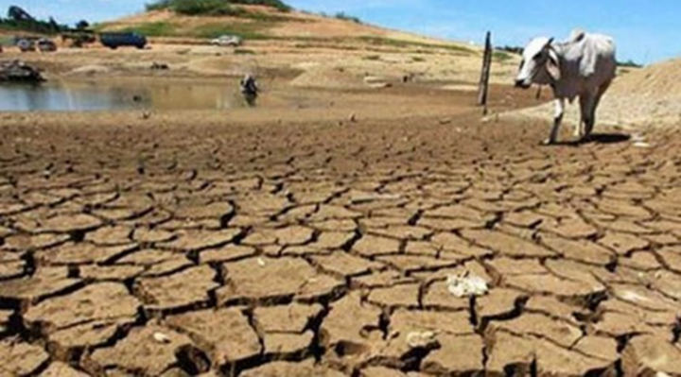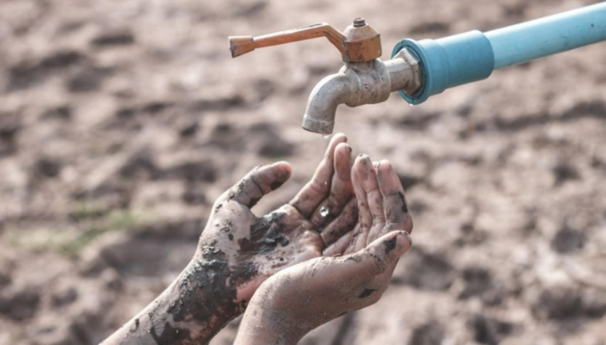

|  |  |  |  |  |
| --- | --- | --- | --- | --- |
| ***Course content & exam structure*** | | | | |
| **Component** | **What’s assessed** | **Questions** | **Question Types** | **How’s it Assessed** |
| ***Paper 1:***  Physical Geography | ***Section A: Water & carbon cycles***  ***Section B:*** Either  Hot deserts systems & landscapes or ***Coastal systems & landscapes*** or Glacial systems & landscapes.  ***Section C:*** Either ***Hazards*** or Ecosystems under stress | ***Section A:*** Answer all questions  36 marks.  ***Section B***: Answer either question 2,3 or 4 36 marks.  ***Section C:*** Answer either question 5 or 6. 48 marks. | * **Multiple choice** * **Short answers** * **Levels of response** * **Extended prose** | 21/2 hour written exam  120 marks  40% of A level |
| ***Paper 2:***  Human Geography | ***Section A: Global systems & global governance***  ***Section B: Changing places***  ***Section C:*** Either Contemporary urban environments or ***Population & the environment*** or Resource security. | ***Section A:*** Answer all questions,  36 marks.  ***Section B***: Answer all questions, 36 marks.  ***Section C:*** Answer either question 3, 4 or 5. 48 marks. | 21/2 hour written exam  120 marks  40% of A level |
| Paper 3: **Geography fieldwork investigation** | Students complete an individual investigation which must include data collected in the field. The individual investigation must be **based on a question or issue defined and developed by the student relating to any part of the specific content** | | 3000-4000 words  60 marks  20% of A level  Marked by teachers  Moderated by AQA examiners | |

***Should water be a privatised asset? Justify your response.***

CNS ‘A’ level Geography transition task ***The Global Water Crisis***

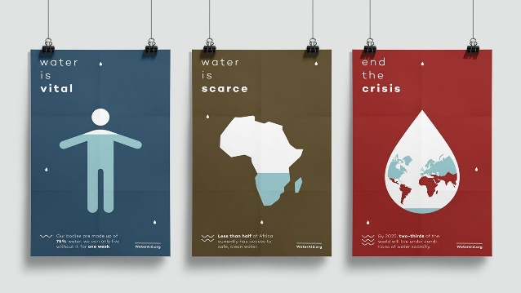Water is a global resource essential to life. However, water is a finite resource and is regarded as an important public asset by most countries. Around 700 million people in 43 countries suffer today from water scarcity and, four billion people, almost two thirds of the world's population, experience severe water scarcity for at least one month each year. England and Wales are the only countries to have fully privatised water supplies in Europe and yet there are some regions of the UK that may begin to suffer from water stress over the coming years. In the coming decades as water supplies become more important natural assets it is predicted that they will also become the most common cause of conflict between countries and/or regions. How do we avoid this and manage water supplies in a sustainable way?

We would like you to research & consider this problem from a social, environmental, economic & political viewpoint and answer this question: Should water be a privatised asset? Justify your response.

[Global water crisis looming, UN says - BBC News - YouTube](https://www.youtube.com/watch?v=hfTB5TgJq5w) (2:33)

[Explained | World's Water Crisis | FULL EPISODE | Netflix - YouTube](https://www.youtube.com/watch?v=C65iqOSCZOY) (18:43)

[The Earth is on the brink of a global water crisis, warns UN - YouTube](https://www.youtube.com/watch?v=nMuD3zkYrZQ) (1:30)

[The Water Crisis | National Geographic - YouTube](https://www.youtube.com/watch?v=3VyfN30XzDM) (44:13)

|  |  |
| --- | --- |
| ***Should water be a privatised asset? Justify your response. (Notes)*** | |
| **Social** |  |
| **Environmental** |  |
| **Economic** |  |
| **Political** |  |
| **Justify your response.** | |

**In no more than 1 page of A4 (350 words max Handwritten)**

***Should water be a privatised asset? Justify your response.***