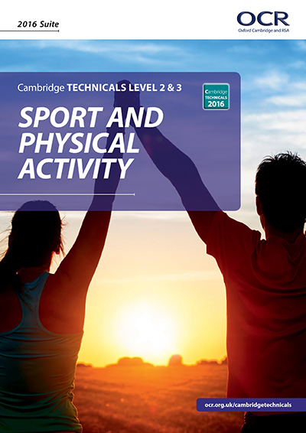 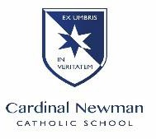 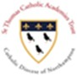

Welcome to Cambridge Technicals PE, also know as Sports Studies. This course helps students achieve their potential and gives students the skills and knowledge required to progress to the next stage of their lives, building on their interest and knowledge of Sport and Physical Activity.

In year 12 students will study;

Body Systems and the effects of Physical Activity (Exam)

Sports Coaching and Activity Leadership (Coursework)

Sports Organisation and Development (Exam)

This leads on to further studies in year 13;

Organisation of Sports Events (Coursework)

Performance Analysis in Sport and Exercise (Coursework)

## TRANSITION TASKS

**Body Systems and the Effects of Physical Activity**

Using your current knowledge of the Skeletal and Muscular System, complete the diagrams below;

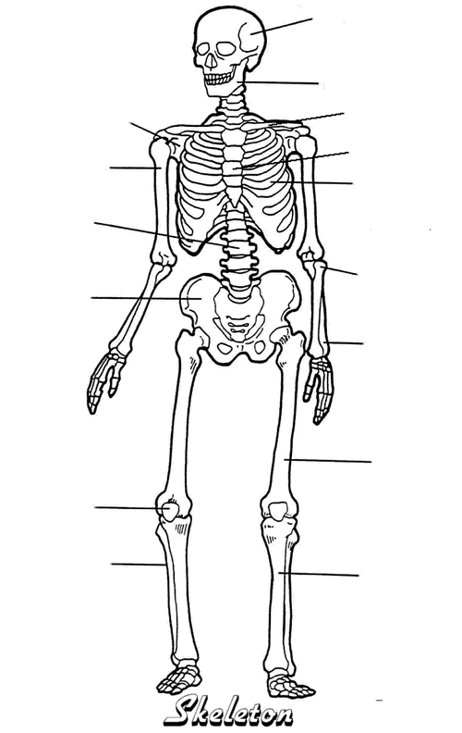

The skeleton has six functions, what do you think these are?

1. P…………………….. 2. S……………….. 3. P………………………
2. M……………………… 5. R…… B…….. C…….. P………………… 6. M…………….. S……………….

**The Structure of the Skeletal System**

|  |
| --- |
| A joint is...  A synovial joint is... |

Using your current knowledge or the Structure of the Skeletal System and types of movement, complete the table below.

|  |  |  |
| --- | --- | --- |
|  | Movement and Description: | Sporting Example: |
|  | **Extension** |  |
|  | **Flexion** | Lifting a weight in a bicep curl |
|  | **Abduction** |  |
|  | **Adduction** |  |
|  | **Rotation**  **Circumduction** |  |