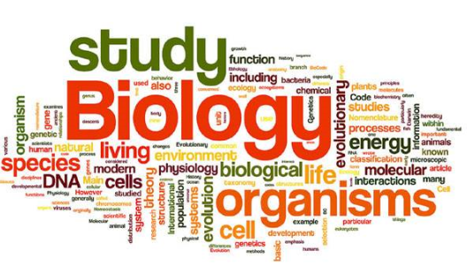

Scan QR code for the A level Biology specification

A Level Biology will give you an exciting insight into the contemporary world of biology. It covers the key concepts of biology and practical skills are integrated throughout the course. This combination of academic challenge and practical focus makes the prospect of studying A Level Biology highly appealing. You will learn about the core concepts of biology and about the impact of biological research and how it links to everyday life. You will learn to apply your knowledge, investigate and solve problems in a range of contexts. You will develop transferable skills including: investigative, problem solving, research, decision making, mathematical and analytical skills.

Studying A level biology can take your post 18 options in many directions some of our recent A level students have gone on to study courses such as: veterinary science, radiography, prosthetics, pharmacy, neuroscience, medicine, dentistry, nutrition, physiotherapy, nursing and environmental sciences

**Transition Tasks**

A level Biology will use your knowledge from GCSE and build on this to help you understand new and more demanding ideas. For your transition task you **must complete tasks A,B and C** and then you will **choose one option from task D .** These tasks are to ensure you will enjoy studying A Level Biology and that you are ready to start the course.

**Please complete your transition task by your first lesson back in September and bring it with you to class.**

Should you have any questions or require any help, please contact Mrs Welch [swelch@cardinalnewmanschool.net](mailto:swelch@cardinalnewmanschool.net) or Miss Daly [cdaly@cardinalnewmanschool.net](mailto:cdaly@cardinalnewmanschool.net)

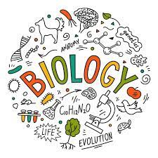

**Expected knowledge**

When you begin the A level Biology course in September, it is essential that you have a secure understanding of the following content and skills. Please ensure that you spend time over the summer holidays making sure you are confident in these areas as they will be assessed at the start of the course. Any student who does not meet the expected level of knowledge will be given additional homework in September to make improvements.

**Key skills that will be assessed at the start of Year 12**

* Naming standard laboratory equipment
* Using standard form and rounding values
* Calculating surface area to volume ratio
* Calculating percentage change
* Using the magnification equation and rearranging it.
* Converting between units (please see next page for help)
* Drawing and using results tables
* Graphing experimental results

**Key content that will be assessed at the start of Year 12**

* Structure of prokaryotic and eukaryotic cells and the roles of the organelles
* Enzyme action and factors affecting enzyme activity
* Structure and function of the heart
* Food tests for glucose, lipids, proteins, starch
* Comparison of electron and light microscopes and how to use a light microscope

**TRANSITION TASKS:**

**TASK A**

Why do you want to study a level biology?

Write a letter to your new A level biology teacher outlining why you want to do the course. You should include any future aspirations you have; for both further study and career options. Use this as your opportunity for your teacher to learn about you and motivations for studying biology. Your letter should be at least 1 page long.

**TASK B**

Research and write a scientific article on an aspect of biology that you find interesting.

This does not have to be related to the A Level specification, but you will need to reference your work. This piece of work will need an introduction, discussion and a conclusion.

* Introduction: The introduction to a research paper is where you set up your topic and approach for the reader. It has several key goals: Present your topic and get the reader interested. Provide background or summarise existing research. Position your own approach.
* Discussion: During a discussion to a research paper, the author describes, analyses, and interprets their findings. They explain the significance of those results and tie everything back to the research questions. Conclusion: A conclusion is not merely a summary of the main topics covered or a re-statement of your research problem, but a synthesis of key points and, if applicable, where you recommend new areas for future research.
* References: please use Harvard referencing; Author name and initials, Title of article or book, title of journal (in italics), publication info (Volume or number), page range, access date, name of database.

If you need more information on how to Harvard reference, please follow this link https://www.scribbr.co.uk/referencing/harvard-style/

You will be sharing your article with your peers in September but you will not be expected to do a presentation.

**TASK C**

**Produce a glossary for the following key words**

* Accuracy
* Anomaly
* Calibration
* causal link
* chance
* confounding variable
* control experiment
* control group
* control variable
* correlation
* dependent variable
* errors
* evidence
* fair test
* hypothesis
* independent
* null hypothesis
* precision
* probability
* protocol
* random distribution
* random error
* raw data
* reliability
* systematic error
* true value
* validity
* zero error

**TASK D**

You must complete at least one of the research tasks from the three below

1. **Therapeutic Use of Stem Cells**

Stem cells are special types of cells that have the ability to self-renew by mitosis and to differentiate. There has been great interest in stem cells due to their potential for tissue repair and for treating a range of degenerative conditions, such as multiple sclerosis and Parkinson’s disease, where neurones and other cells in the nervous system have been damaged or have lost their ability to function. There is great potential to use stem cells to replace damaged cells. Although most of the therapeutic uses of stem cells are at an early stage, many scientists and researchers believe that stem cell treatment will one day be able to cure many human diseases and relieve suffering.

Carry out research on the therapeutic uses of stem cells and prepare a presentation in the form of a poster or on PowerPoint.

Your presentation should cover the following points:

• What stem cells are and how they are different from body cells.

• Where stem cells are found.

• The difference between embryonic stem cells and adult stem cells.

• An explanation of the therapeutic use of stem cells in treatment of lymphomas.

• A discussion of at least three potential uses for this type of therapy.

• A discussion of any risks of stem cell therapies.

• Those who would benefit most from stem cell therapy.

• Why there are such varied attitudes to stem cell research.

**Human Impact on the Environment**

The natural environment is very important to humans, both for economic and social reasons. Humans have exploited the environment and its natural resources for many commodities, including resources for food, energy and medicine, and land for agriculture and building. A rapid increase in the human population has led to a growing demand for the Earth’s precious resources and has resulted in widespread damage to a range of ecosystems. Raw materials such as coal, oil and natural gas are being used up at an alarming rate.

Prepare a research project titled ‘Human Impact on the Environment’. You will need to research how humans have exploited the environment for resources and be able to explain the consequences both of extracting and of actually using these resources.

You should prepare a poster or PowerPoint presentation to share your research with your fellow classmates. You must highlight some of the following points:

• What are non-renewable energy resources.

• How the combustion of fossil fuels affects the atmosphere.

• What the greenhouse effect is.

• How greenhouse gases are linked to global warming.

• The effect of global warming on plants and animals.

• The long-term effect of deforestation on the environment and on biodiversity.

You may use other examples to explain human impact on the environment.

**Lifestyle and Disease**

Lifestyle choices have a great impact on individuals and on society. Lifestyle diseases are more evident, and occur more frequently, in industrialised societies. These diseases linked to our lifestyles are on the increase and there are now many campaigns highlighting the dangers and health issues linked with the different ways we live our lives. Prevention is usually the best way to approach these problems and it is very important to make people aware of the consequences of an unhealthy lifestyle and the risk of many associated diseases. Some of the major factors that have had a dramatic impact on health over recent years include:

All these risk factors are linked to an increased chance of developing diseases such as lung cancer, coronary heart disease, liver cirrhosis and diabetes.

Write an informative leaflet highlighting the importance of a healthy lifestyle, that could be used as part of a healthy lifestyle awareness campaign in your school or college. You should discuss a range of lifestyle choices and explain how they are linked to diseases.

Your leaflet must include the following points:

• What is health and what is a disease.

• The effects of smoking cigarettes on the body (link this to some of the chemicals found in tobacco).

• How drinking alcohol affects your physical and mental abilities.

• What is an unbalanced diet.

• The links between high fats and cholesterol in diet and coronary heart disease.

• What are cardiovascular diseases.

• The benefits of regular exercise on the body

**Enrichment Activities**:

If you are on holiday in the UK, or on a staycation at home, why not plan a day trip to one of these:

Remember there are also lots of zoos, wildlife and safari parks across the country, here are some you may not have heard of and could consider visiting: **Whipsnade Zoo (Bedfordshire), Woburn Safari Park (Bedfordshire)**, Colchester Zoo, Cotswold Wildlife Park, Banham Zoo (Norfolk), Tropical Birdland (Leicestershire), Yorkshire Wildlife Park, Peak Wildlife Park, International Centre for Birds of Prey (York), Blackpool Zoo, Beale Park (Reading).

There are also hundreds of nature reserves (some of which are free) located all over the country including:

RSPB sites at **Sandy (Bedfordshire),** Lochwinnoch, Saltholme, Fairburn Ings, Old Moor, Conwy, Minsmere, Rainham Marshes, Pulborough Brooks, Radipole Lake, Newport Wetlands. Wildlife Trust Reserves and others at Rutland Water, Pensthorpe, Insh Marshes, Attenborough Centre, Inversnaid, Skomer, Loch Garten, Donna Nook, Chapmans Well, Woodwalton Fen, London Wetland Centre, Martin Down and Woolston Eyes Reserve.

**Natural History Museum in Tring (Hertfordshire)** or London

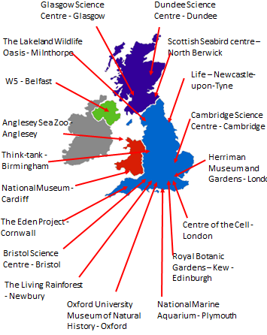

**Biology Book Recommendations**

Alice Roberts:

* Tamed: Ten Species that Changed our World
* Evolution: The Human Story
* Anatomical Oddities
* The Incredible Unlikeliness of Being
* The Incredible Human Journey

Richard Dawkins:

* The Selfish Gene
* Climbing Mount Improbable
* The Ancestor’s Tale

Steve Jones:

* Y: The Descent of Men
* In the Blood: God, Genes and Destiny
* Almost Like a Whale: The 'Origin of Species' Updated
* The Language of the genes

Matt Ridley

* Genome: The Autobiography of a Species in 23 Chapters
* The Red Queen: Sex and the Evolution of Human Nature
* The Language of Genes
* Francis Crick: Discoverer of the Genetic Code
* Nature Via Nurture: Genes, Experience and What Makes Us Human

James Watson:

* DNA: The Secret of Life
* The Double Helix: Personal Account of the Discovery of the Structure of DNA

Lewis Thomas:

* The Lives of a Cell: Notes of a Biology Watcher
* The Medusa and the Snail: More Notes of a Biology Watcher Barry Gibb: The Rough Guide to the Brain (Rough Guides Reference Titles)

Charles Darwin

* The origin of species

Bill Bryson

* A Short History of Nearly Everything

Oliver Sachs

* The Man Who Mistook His Wife For A Hat

**Useful Websites**

1. http://www.ibiblio.org/virtualcell/index.htm – An interactive cell biology site

2. http://www.accessexcellence.org/RC/VL/GG – A web site showing illustrations of many processes of biotechnology

3. http://www.uq.oz.au/nanoworld – Visit the world of electron-microscopy

4. http://www.dnai.org/a/index.html – Explore the genetic code

5. http://nobelprize.org – Details of the history of the best scientific discoveries

6. http://nature.com – The site of the scientific journal

7. http://royalsociety.org – Podcasts, news and interviews with scientists about recent scientific developments

8. http://www.nhm.ac.uk – The London Natural History Museum’s website with lots of interesting educational material

9. http://www.bmj.com – The website of the British Medical Journal

10.http://www.bbc.co.uk/news/science_and_environment - The BBC news page for Science and the Environment