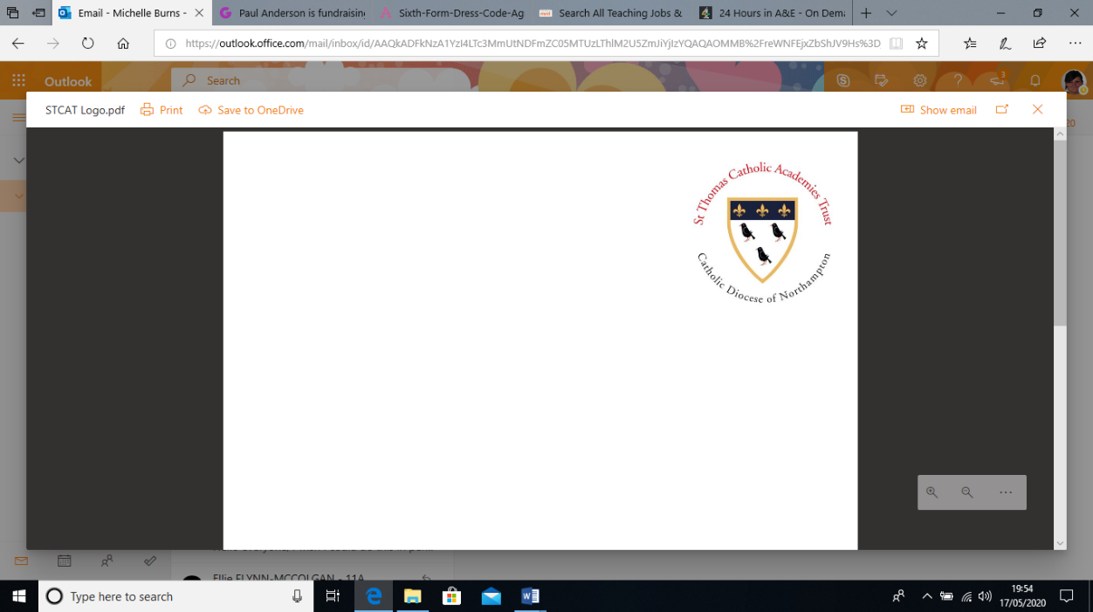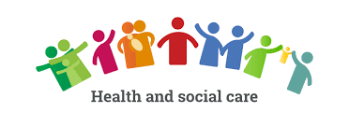

Welcome to BTEC Leve 3 Health and Social Care! Health and Social Care covers a wide variety of areas and topics which are relevant to modern day society. You will look at how legislation plays a big part in all the services we use throughout our lives, whilst also covering areas such development that occurs at different stages of our life and what working in health and social care feels like. Please complete our transition task by your first lesson back in September.

**COMPULSORY TRANSITION TASK**

**[](https://www.google.com/url?sa=i&url=https://gizmostory.com/2020/02/10/after-life-season-2-is-arriving-on-netflix-things-to-know-about-the-future-the-latest-update/&psig=AOvVaw1ZRWeliXuGNT77XVv4zBls&ust=1589538850568000&source=images&cd=vfe&ved=0CAIQjRxqFwoTCJi_ifOTs-kCFQAAAAAdAAAAABAE)Written-based task 1**

You will need to watch the Netflix series ‘After Life’, you do not need to watch the whole series, however the more you watch the more you will have to discuss. There is an overall question, within this question there will be a number of areas you will need to discuss, which is typical of health and social care.

There is not just one website available to help you, however if you Google specific areas you will find a wealth of information available to you. If you struggle with any of the terminology please feel free to email me on [mburns@cardinalnewmanschool.net](mailto:mburns@cardinalnewmanschool.net) and I will be happy to help.

You should at least attempt the question and all the different components within the question. Present this typed up on a Word document. The minimum word requirement is 500 words for this piece of work. Those who also complete the push yourself question will receive an added bonus!

**Question – What are the emotional, social and intellectual challenges faced by the main character and how could these impact the individual in the short term and long term. What support and personalised approaches could be used to support the individual and how would these benefit them in the short term and long term.**

**Success criteria:**

* In order to cover all the sections of the question you should break this down into roughly 4 paragraphs
* Within each paragraph you will need to identify a challenge linked to one of the areas the question has asked you to discuss – for example emotional challenges
* Using the challenge you have identified you will need to discuss what possible short and long term effects this would have on the individual
* The final paragraph should look at what support can be put into place to support the individual with the challenges you have identified

**Some ideas for you to explore:**

* The changes you are able to recognise in the main character Tony – linking to the short term and long term impacts his situation has had on him
* What support is offered to those who are suffering this kind of bereavement? – This will help you answer the part about support in the short and long term
* What impact can bereavement have on an individual’s health and wellbeing? – This will help you to make links to what the main character may be suffering or dealing with

**Want to challenge yourself?** Using Erikson’s psychosocial developmental theory discuss how the main characters significant life event would impact their transition through the different stages in Erikson’s theory.

**Wider Reading and Preparation for Level 3 Task 1**

**[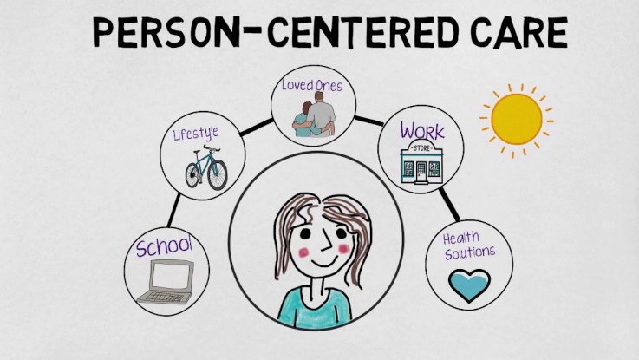](https://www.google.com/url?sa=i&url=https%3A%2F%2Fwww.youtube.com%2Fwatch%3Fv%3D3zFvzXxlcP4&psig=AOvVaw39xBgveNpOM2PPcTorqn3v&ust=1589726022036000&source=images&cd=vfe&ved=0CAIQjRxqFwoTCNjj5ZXNuOkCFQAAAAAdAAAAABAE)Personalisation and a person-centred approach**

* What is personalisation and a person-centred approach?
* Research online the difference between using a personalised approach and a person-centred approach?
* Why were these approaches introduced?

**Read the article**

Read the following article about why it is important to treat the patient not just the disease - <https://www.reviewofophthalmology.com/article/treat-the-patient-not-just-the-disease>

As you will see from the article there has been the continuing argument that treating the whole person has a long lasting positive impact on their health and wellbeing. However there has been a struggle to get practitioners to change the way they work in order to use this approach.

**Wider Reading and Preparation for Level 3 Task 2**

**[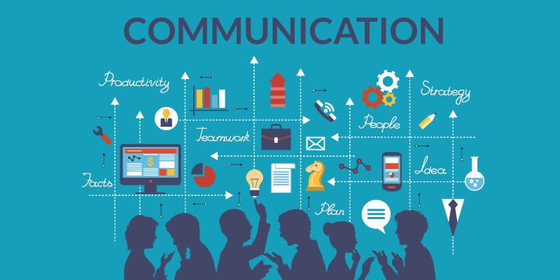](https://www.google.com/url?sa=i&url=https%3A%2F%2Fwww.rencaigroup.com%2Fimportant-of-communication-within-hr-projects%2F&psig=AOvVaw1nZQvIw7lqagLoteE8330p&ust=1589726061013000&source=images&cd=vfe&ved=0CAIQjRxqFwoTCNjar6jNuOkCFQAAAAAdAAAAABAK)Communication in Health and Social Care**

In order to ensure that the services are able to meet the needs of the individuals it is important they maintain high level of communication not just with the individual requiring treatment, but also between themselves.

**Listen to the Podcast**

The following radio extract listens to a group of professionals discussing the cases they are working on. By listening to this piece you will see the importance of multi-disciplinary working within Health and Social care settings.

In sickness and in social care – <https://www.bbc.co.uk/sounds/play/b0938tnl>

* What is a multi-disciplinary team?
* What are the benefits of a multi-disciplinary team?
* Why are professionals working towards giving patients more control over their after care?

**Types of communication**

There are many different types of communication, some are verbal and some are non-verbal. There are also written types of communication and specialist types of communication. To gain some more understanding of the different types of communication and how these may be used read the information in the link below, which will help to give you a wider understanding. Make links to how these can be used in health and social care.

[](https://www.google.com/url?sa=i&url=https%3A%2F%2Fwww.vecteezy.com%2Fvector-art%2F554841-lightbulb-vector-icon&psig=AOvVaw1UKzYuit7Y_GI6zSBhEnep&ust=1589729135517000&source=images&cd=vfe&ved=0CAIQjRxqFwoTCMCpq-LYuOkCFQAAAAAdAAAAABAE)**Read the article** - <https://courses.lumenlearning.com/atd-tc3-management/chapter/different-types-of-communication/>

**How does communication link to a person-centred approach? How can communication enhance a person-centred approach?**

[](https://www.google.com/url?sa=i&url=https%3A%2F%2Fwww.egi.co.uk%2Fmental-health%2F&psig=AOvVaw1PbIEUFKJ5OJFauevl9ot3&ust=1589814358402000&source=images&cd=vfe&ved=0CAIQjRxqFwoTCPCZhKCWu-kCFQAAAAAdAAAAABAE)**Wider Reading and Preparation for Level 3 Task 3**

**Supporting People with Mental Health Conditions**

One thing that has become extremely important for the NHS and social care services in recent years is the issue of mental health. This has been an ever growing problem, effecting all age groups. The growth in demand for mental health services has never been so high. The clip from a BBC Panorama episode looks into the challenges faced by NHS services.

**Watch the clip -** <https://www.youtube.com/watch?v=DUoyVVeMtpA>

As you watch answer the following questions;

* What are the challenges faced by mental health services? How do these challenges impact on the care which can be provided?
* What is the aim of a professionals meeting?
* Are we truly able to help those in need and what do you think needs to change?

**Living with mental illness**

[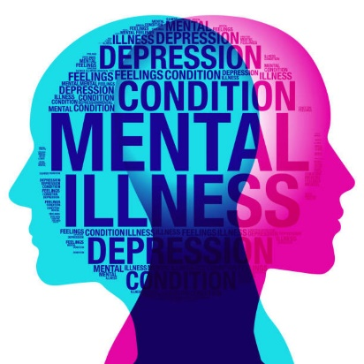](https://www.google.com/url?sa=i&url=https%3A%2F%2Fnewcastlefrontrunners.co.uk%2Frunning-for-mental-health%2F&psig=AOvVaw1E3-YLqA4FJY2jlyJq6my4&ust=1589816539764000&source=images&cd=vfe&ved=0CAIQjRxqFwoTCJitmrCeu-kCFQAAAAAdAAAAABAE)There are many different types of mental illness that can affect people in a range of different ways. Some of the illnesses that can impact an individual are;

* Bi-polar disorder
* Depression
* Anxiety disorder
* Schizophrenia
* Eating disorders
* Borderline Personality Disorder
* OCD – Obsessive Compulsive Disorder

**Watch the clip -** <https://www.nami.org/Personal-Stories/You-ve-Got-This>

**[](https://www.google.com/url?sa=i&url=https%3A%2F%2Fwww.vecteezy.com%2Fvector-art%2F554841-lightbulb-vector-icon&psig=AOvVaw1UKzYuit7Y_GI6zSBhEnep&ust=1589729135517000&source=images&cd=vfe&ved=0CAIQjRxqFwoTCMCpq-LYuOkCFQAAAAAdAAAAABAE)Thinking about what you have just watched, what were the effects of her mental health condition on their day to day life? What type of treatments were offered to her and how well did these work for her?**