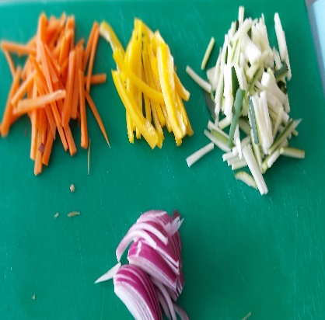**Food Preparation and Nutrition**

**Year 7** is all about Getting to know the food room, food hygiene and safety, developing knife skills and an introduction to Healthy Eating. In Year 7 students make predominantly savoury dishes which ties in perfectly with the government’s expectations of the subject at KS3. This is outlined below:

* Understand and apply the principles of nutrition and health.
* Cook a repertoire of predominantly savoury dishes so that they are able to feed themselves and others a healthy and varied diet.
* Become competent in a range of cooking techniques [for example, selecting and preparing ingredients; using utensils and electrical equipment; applying heat in different ways; using awareness of taste, texture and smell to decide how to season dishes and combine ingredients; adapting and using their own recipes.
* Understand the source, seasonality and characteristics of a broad range of ingredients.

With this focus in mind students are introduced to a range of new ingredients and cooking methods. Students mainly work independently in practical lessons with guidance from the class teacher. Theory lessons are also an important part of the subject and home work is frequently given so that students can continue learning outside the school environment.

An ingredient list of all the dishes student will be making in Year 7 is shared with parents and the ingredients for each lesson is shared weekly on ‘CLASS CHARTS’ so that students can bring in what is needed for practical lessons. The students are often given the opportunity to bring in a choice of ingredient(s) to add to their dish. This helps to develop creativity and also introduces students to learn how dishes can be adapted to suit different dietary needs based on culture, religion, health and ethics.

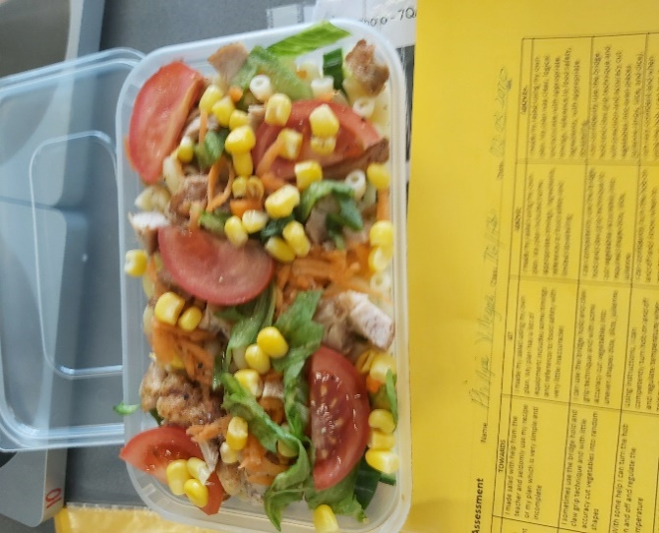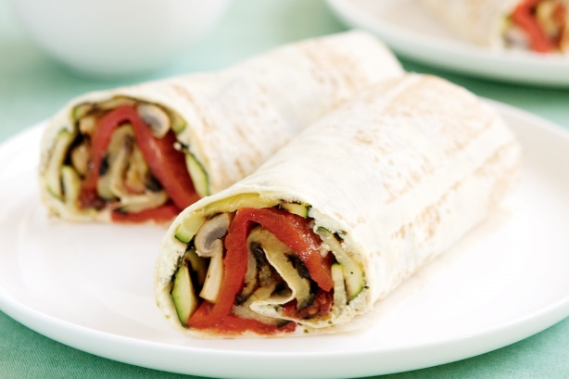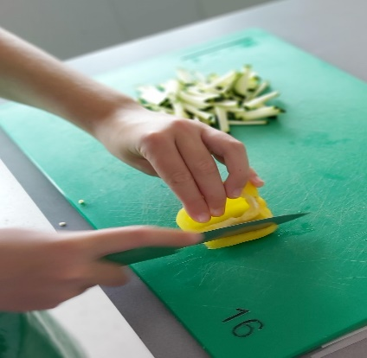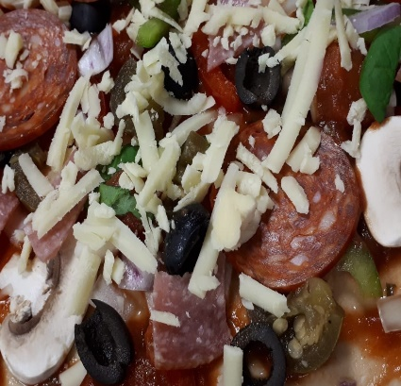 **Mrs Wint, Ms Ruault and Mrs Motyl**