HISTORY
Ms E Thoulass
Miss S Keane
Mr T Kirby
Miss Welch
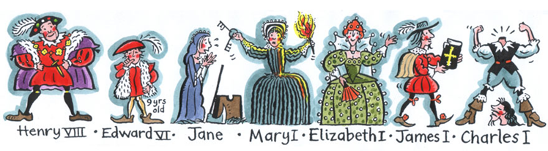
What will you be studying in History at Cardinal Newman Catholic School?
- Name the topics
- Spot the odd one out
- What links all the topics together?

Once you have answered the questions see us to explain your answers and for a sticker if you are correct!Welcome to the History Department
Aim of the History Department
Our vision in History is to encourage interest in, and enjoyment of, learning about the past. Our aim is to help students understand how, why and when things have changed over time developing their understanding of our world and country today. We actively encourage students to think for themselves, using research and evidence gathering so as to develop their own interpretation of the past thereby reaching supported judgements. Through History, students develop empathy and an understanding of personal motivation, in addition to the ability to communicate their thoughts and ideas clearly both verbally and in writing. Our goal is for students to acquire knowledge and skills in History which will serve them well in other subjects, with their educational and career aspirations and allow them to become active and engaged British citizens who understand their democratic past.
Key Stage 3 History
History in Year 7 focuses on early British History up to the 18th century. Topics include the Battle of Hastings, castle building, the Magna Carta, the Black Death. For the Tudor and Stuart periods we examine the nature of English society in a time of major religious, political and social change.
Year 8 History considers ideas, political power, industry and empire in Britain, 1745-1901. We start with our students investigating the Industrial Revolution. We look at how industrial change transformed Britain and had far reaching effects on society and Britain’s political system. We then focus on Britain’s role in the transatlantic slave trade and its abolition up to the civil rights movement in the 1960s and consider the impact that these issues had on Britain.
Year 9 History covers the modern period and considers Challenges for Britain, Europe and the wider world 1901 to the present day. This includes the causes and consequences of World War 1 and 2, the rise of Nazi Germany, the Holocaust and the Cold War
Key Stage 4 History:
Students investigate the exciting events in Germany between 1918 and 1939; Medicine in Britain, c1250 to present with The British sector of the Western Front, 1914–18 Trench warfare: injuries, treatment and the trenches; Anglo-Saxon and Norman England, c1060–88 and The American West, c1835–c1895

All components of the course are assessed through three external examination at the end of Year 11 (Edexcel History GCSE Paper 1 1HI0/10-12: 11; Paper 2 1HI0/20-29:B1 24/25; Paper 3 1HI0/30-33:31)

