Media Studies
- Our course can help students develop their analytical skills and ability to construct an argument both verbally and in their written, which would bolster their confidence in subjects such as English and History.
- We offer the creative element of course work which allows students to be innovative and showcase their practical skills.
Why Study Media Studies in Year 9 at Cardinal Newman?
- We are an Outstanding Department and achieve excellent GCSE results.
- We have a range of modern equipment that students are free to use at any time.

Mrs Walker (Head of Department), Mrs Frazer and Miss Blackbird
Overview
Media Studies at Cardinal Newman is a contemporary and dynamic subject that offers students the opportunity to study an intellectually stimulating and contextually relevant range of exciting products. As well as engaging with a plethora of rich and stimulating texts, students will be expected to apply their understanding to a creative practical piece of their own design. If you are the sort of student who enjoys debating current issues such as the representation of Brexit in national newspapers; who likes analysing meaning in historical and contemporary texts such as women in Vogue in 1969 compared to today; and who wants to produce their own media text, then Media Studies is the choice for you!
What will the course involve?
In year 9 you will be introduced to the main concepts that underpin the subject and also the opportunity to create different media products such as a website, adverts and film marketing, magazines and a music video. You will learn how to use Wix, Photoshop Elements and Premier Pro Elements.
In Year 9 students will start to explore elements of  Exploring the Media | In Year 9 students will start to explore elements of  Understanding Media Forms and Products | In Year 9 students will produce 5 different media products  Media Production
Products that we shall study in Year 9 may include any of the following:  - GQ Magazine  - Vogue Magazine  - Advertising campaigns from 1960’s and 2010’s  - Film marketing campaigns such as Black Panther | Products that we shall study in Year 9 may include any of the following:  - Little Mix ‘Shout out to my Ex’  - Ed Sheeran ‘Shape of you’  - Justin Bieber ‘Intentions’ | Students will be given the opportunity to explore their creative ideas linked to brief. The briefs for Year 9 are as follows:  - Advertising: create a music video to promote a new band  - Magazines: create a print or online-based magazine.  - Websites: Create your own website for a new film.
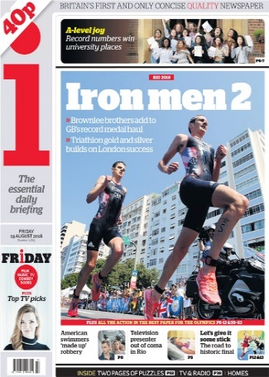
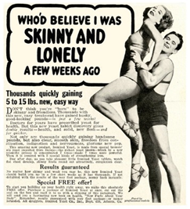
Look out for our Year 8 film making club!

