**C:\Program Files\Microsoft Office\MEDIA\OFFICE14\AutoShap\BD18223_.wmfC:\Program Files\Microsoft Office\MEDIA\OFFICE14\AutoShap\BD18223_.wmfMusic**

**Mr. S. Carter**

**Curriculum**

**In Year 7,** pupils receive a fortnightly music lesson. Throughout the year the elements of music are taught through the activities of performing together, composing and focused listening to music.

**In Year 8**, pupils also receive a fortnightly lesson. They will study styles from around the world, as well as music history from the Baroque to the present, through the activities of performing together, composing and focused listening to music.

**In Year 9** pupils receive three lessons per fortnight and build music performance and composition skills. During this time, pupils focus on their chosen instrument or singing and gain experience in Solo and ensemble performing. Music Technology is introduced into composition, with access to our Apple Mac computers, which are equipped with the ‘Garageband’ music software.

**In Years 10 and 11** Pupils now will receive two lessons per week. They will beginthe OCR course in Music to GCSE level. This is currently delivered to a small class of around 12-15 pupils. Candidates are required to perform Solo and as part of an ensemble, compose music in different styles and complete a written listening paper.

All classes are practical based and pupil feedback shows that they enjoy music lessons.

**Extra-Curricular** **Ensembles**

The Department has a variety of ensemble groups. They are often called upon to perform in concerts in and out of School as well as Masses and Liturgies. There are regular performances in the community and our Choir/Orchestra perform annually at Luton Airport at Christmas. Photos from our airport performance, as well as our 2022 production of ‘Chicago’ are proudly on display in the Music Block.

Our extended curriculum groups include;

**Steel Band School Choir School Orchestra The Cardinals Rock Band**

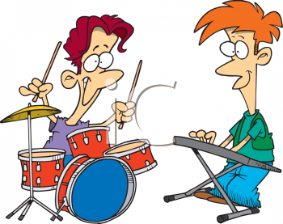 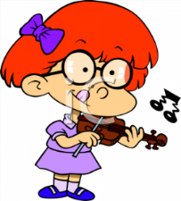

**C:\Program Files\Microsoft Office\MEDIA\OFFICE14\AutoShap\BD18223_.wmfC:\Program Files\Microsoft Office\MEDIA\OFFICE14\AutoShap\BD18223_.wmf**

**Instrumental/Voice lessons**

We are fortunate to have a team of approved peripatetic teachers as well as ones provided by the Luton Music Service. Many of these also teach in our feeder schools. If your child is playing an instrument already, there is a chance that they will have the same teacher when they arrive at Cardinal Newman. There are roughly 40 Students receiving instrumental or vocal tuition presently.

Our Peripatetic Staff are;

**Mr C Doggett** – Cello

**Mr S Router** – Brass (Trumpet, French Horn, Euphonium)

**Mrs J Fraser** – Voice

**Miss C Frost** – Woodwind (Flute, Clarinet, Saxophone)

**Mr R Abji** - Guitar/Bass guitar

**Mrs V Parkes** -Violin/Viola

**Mr T Parkes** – Piano

**Mr W Strachan** – Drum Kit/Percussion

At present, Voice, Drums and Violin lessons are provided by Luton Music Service, who will invoice you for the lessons in advance. All other instruments are taught on a private basis. Fees very between each approved teacher, depending on their rates and you will pay the teacher directly.

**Accommodation**

We have a large classroom where the curriculum is delivered and two practice rooms which are used for instrumental lessons and practicing. We also work closely as a Performing Arts Department and regularly use the Hall for our joint Shows and Concerts.

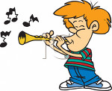 [](http://www.google.co.uk/url?q=http://www.clipartbest.com/guitar-cartoon-images&sa=U&ei=xgogVJX2AoLkaLKPgdgB&ved=0CC4Q9QEwDA&sig2=QuLaSe0PdcRLeYRr3AfThQ&usg=AFQjCNHVwCfTq7onvwJPULDX-Zr9zWNwYw) 