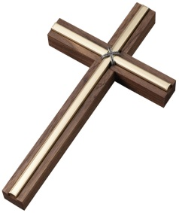RE Department

**The RE Teachers**

Mr. Lawrence Makokha Curriculum leader

Mrs. Emma Finn Assistant Curriculum leader

Mrs. Lidia Kidman Part - time in the Department

Dr. Patrick Businge Full - time in the Department

Mr. Karsten Wille Full - time in the Department

Mr. Marc Forni Full - time in the Department

Mrs. Verity Roulston Full - time in the Department

Mrs. Ngozi Igweani-Gilmartin Part - time in the Department

Miss. Blessy Joseph Full - time in the Department

Miss Alice Clothier Full - time in the Department

The ‘heart of the school’

[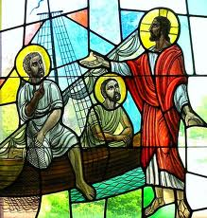](http://www.google.co.uk/imgres?um=1&sa=N&biw=1280&bih=929&hl=en&tbm=isch&tbnid=skzrOcoAaLP6xM:&imgrefurl=http://www.thecatholicsteward.com/2012/01/10/stewardship-bulletin-reflection-on-lectionary-readings-january-22-2012/fishers-of-men-3/&docid=N9VRGQcluXjZkM&imgurl=http://www.thecatholicsteward.com/wp-content/uploads/fishers-of-men-3.jpg&w=608&h=640&ei=flFBUuCiB8OStAbXiIHABQ&zoom=1&ved=1t:3588,r:65,s:0,i:292&iact=rc&page=3&tbnh=183&tbnw=174&start=46&ndsp=27&tx=84&ty=97)C:\Users\ypi.CNS\AppData\Local\Microsoft\Windows\Temporary Internet Files\Content.IE5\9CQ5ACL5\MC900048036[1].wmf

**Our Vision**

In the RE Department we hope and we pray that through our teaching of the mystery of God, the mystery of the life, death and resurrection of Jesus, the teachings of the Church and the beliefs that Catholics hold, our students will be led to question, reflect on and deepen their faith. We want them to develop the appropriate skills and attitudes to enable them to respond fully to God’s call to them in everyday life and in doing so to choose to use the gifts and talents entrusted to them by God to the fullest of their potential in the service of Him and the service of others.

We hope too that they will come to the knowledge that they are truly sons and daughters of God. We pray they will know the truth of the Father’s deep love for each of them, enabling them to grow in their relationship with Christ. We believe that a strong relationship with Christ will give them the strength to take their place in the Church and in society and make a positive contribution to our world, able to withstand its pressures, difficulties and challenges.

"Dear young people, you too are called to be "fishers of men”. Do not hesitate to spend your life with joy to witness to the Gospel; your contribution is vital to the mission of the Church, which is to spread God’s Word: the young are the apostles of youth! Tell everyone with your life, with your joy, that Jesus and his message is always current. And this is why you have the courage to go against the tide, do not be driven by the currents, set sail with Jesus to bring his message to the world”

(*Pope Francis - message to young people. September 2013)*

**Facilities in the RE Department**

All RE lessons are taught in six of the new purpose-built classrooms in Littlemore House. Each room is well furnished, with digital projector and white board. Each room has pin boards which are used to display and celebrate pupils work.

[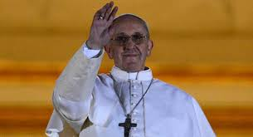](http://www.google.co.uk/imgres?um=1&hl=en&biw=1280&bih=929&tbm=isch&tbnid=5UuW8sNBLRic4M:&imgrefurl=http://ccchristology.wordpress.com/2013/03/13/pope-francis-ch-4-test-class-tomorrow/&docid=_QQhJzyLRKylBM&imgurl=http://ccchristology.files.wordpress.com/2013/03/pope-francis.jpg&w=605&h=328&ei=hmdBUt_EAYnIswalioGICw&zoom=1&ved=1t:3588,r:28,s:0,i:172&iact=rc&page=2&tbnh=165&tbnw=277&start=23&ndsp=25&tx=176&ty=81)[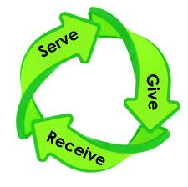](http://www.google.co.uk/imgres?um=1&hl=en&biw=1280&bih=929&tbm=isch&tbnid=1A-A9u69Oi2BaM:&imgrefurl=http://oraclesoftruth.org/selfless-service-opportunities/&docid=1-jpVGzNEktBOM&imgurl=http://oraclesoftruth.org/wp-content/uploads/2012/05/give_receive_serve-1024x1021.jpg&w=1024&h=1021&ei=KWlBUuvGLYOItQbh-YCoBA&zoom=1&ved=1t:3588,r:50,s:0,i:238&iact=rc&page=3&tbnh=188&tbnw=187&start=48&ndsp=29&tx=106&ty=78)

**Key Stage 4**

Students have five one-hour lessons of RE every two weeks. We follow the WJEC Eduqas GCSE courses in Religious Studies.

We teach these courses because we believe they offer an exciting and relevant opportunity for students to explore their faith and consider religious and other responses to important moral and social issues. Students will also get the opportunity to study other faiths including Judaism.

**Key Stage 3**

At Cardinal Newman students have five one-hour lessons of RE every two weeks. In keeping with the Bishops’ Curriculum Directory, approved by the Catholic Bishops’ Conference of England and Wales, we use the Way, the Truth and the Life series, supported by different resources to enable our students to explore Christian beliefs and practice according to the Roman Catholic Tradition.

C:\Users\Yvonne\AppData\Local\Microsoft\Windows\Temporary Internet Files\Content.IE5\XRFQJ7GE\MC900097247[1].wmf

**Prayer and Reflection in RE.**

We begin each lesson with a prayer and as far as possible we follow the liturgical calendar, drawing the students’ attention to the seasons of the Church’s year and Feasts and incorporating this into our prayer.

We believe that faith is ‘caught’ not ‘taught’ and so we strive, as best we can, in our words and above all in our actions to reflect the Gospel message to our students:

“You must live your whole life according to the Christ you have received – Jesus the Lord; you must be rooted in him and built on him and held firm by the faith you have been taught and full of thanksgiving.” *(Colossians 2:6-7)*

**What are the lesson activities?**

During lesson time pupils will be involved in a range of activities including discussion, pair work, group work, role play and research from books and the Internet.

**Independent Study**

Independent Study is set regularly each half term and can be accessed on the school’s Virtual Learning Environment on the school website and on class charts. This involves a range of activities including reading, research, and project work and preparing presentations.

**Assessment**

Pupils’ Independent Study and class work are assessed continually during the term. There are three formal assessments in RE during the year, one each term.

**Celebrating our success!**

We are very proud of our excellent GCSE and A-level results. We are consistently achieving above the national average in both exams. This year, 70% of our GCSE students achieved grades 9-4. We attained ALPS 2 in the A-level exams.

**Trips:** We offer a range of trips including the trip to Rome which is set to resume soon having been interrupted by Covid -19 restrictions.

**Key Stage 5**

All students are given the opportunity to develop their faith in the Sixth Form through retreats, RE lessons and conferences. A number of students take up the OCR Philosophy and Ethics A-level course.