

**Criminology**

Welcome to Applied Criminology!

This Level 3 qualification looks at the types of crime that take place

within our society. How do we decide which behaviour is criminal?

How do we explain why some people commit crime and how can we

use different theories of criminality to explain this behaviour? You will

study real life cases in order to gain an understanding of the criminal justice system from the crime scene

all the way to the courtroom and look at how social control is achieved within our society. Criminology is a

challenging subject, requiring commitment and hard work. Ultimately though, the hard work is rewarded

with a deeper understanding of people and society, and perhaps even yourself! Please complete our

transition task by your first lesson back in September.

Should you require any help or if you have any questions, then please contact any members of the Social

Sciences Department.

**COMPULSORY TRANSITION TASK**

1. Make a list of 5 crimes that you have heard about recently – these

could be in your local area, nationally reported or even international.

2. For each of the crimes you have listed, which people are the victims

of these crimes and who are the offenders?

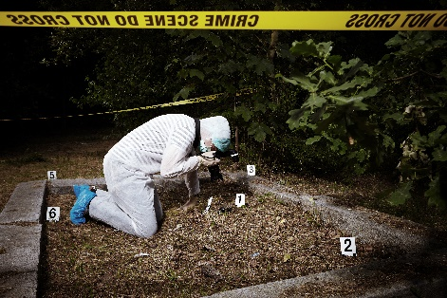3. How have the media and the public reacted to the crimes you have

chosen?

4. Why do you think the media and public reacted in this way?

**EXTENSION TASK**

Research a miscarriage of justice – a case where the wrong person/people were convicted of a crime they did not commit. How and why did this happen? What was the final outcome eg. was the real offender ever caught and punished for their crime(s)?